**Data Collection and Preprocessing Phase**

|  |  |
| --- | --- |
| **Section** | **Description** |
| Data Overview | 583 rows × 11 columns |

|  |  |
| --- | --- |
| Date | 13 july 2024 |
| Team ID | 739805 |
| Project Title | Prediction and Analysis of Liver Patient Data Using Machine Learning |
| Maximum Marks | 6 Marks |

**Data Exploration and Preprocessing Template**

Identifies data sources, assesses quality issues like missing values and duplicates, and implements resolution plans to ensure accurate and reliable analysis.

|  |  |
| --- | --- |
| Univariate Analysis |  |

|  |  |
| --- | --- |
| Bivariate Analysis |  |
| Multivariate Analysis |  |

Outliers and Anomalies

**Data Preprocessing Code Sc**

**reenshots**

Loading Data

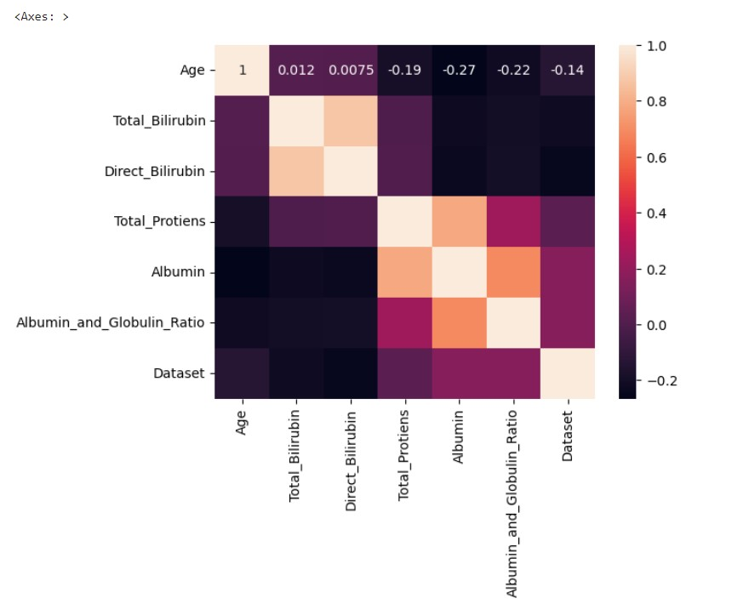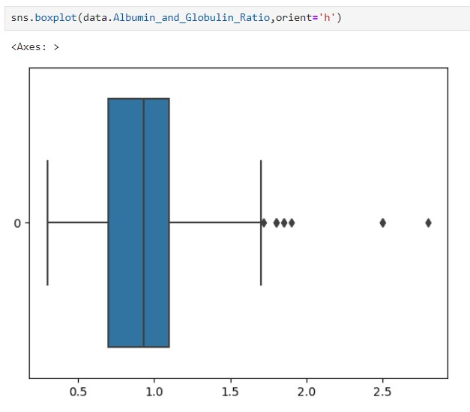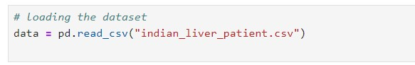

|  |  |
| --- | --- |
|  |  |
| Handling Missing Data |  |
| Data Transformation |  |
| Feature Engineering |  |

|  |  |
| --- | --- |
| Save Processed Data |  |